Sketch Diagram With Assignements
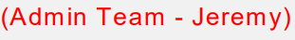


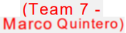


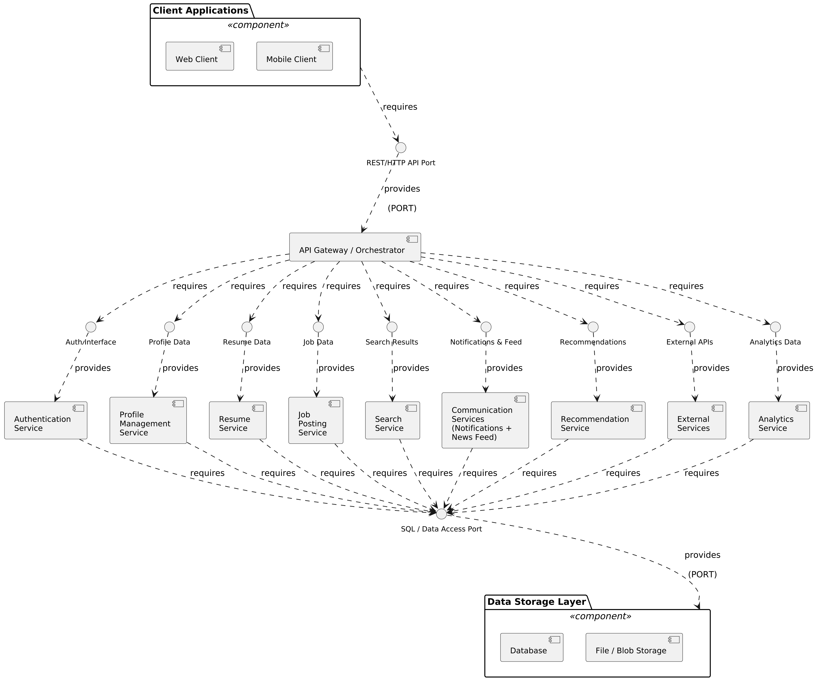

Milestone 1 Team Assignments
- Admin Team (Jeremy) —> Client Applications
- Team 3 (Spencer Beals) —> Web Client
- Team 3 (Spencer Beals) —> Mobile Client
- Team 6 (Robert Anderson) —> API Gateway / Orchestrator
- Team 4 (Kimberly Uresti) —> Authentication Service
- Team 4 (Kimberly Uresti) —> Profile Management Service
- Team 7 (Marco Quintero) —> Resume Service
- Team 2 (Savannah Harvey) —> Job Posting Service
- Team 2 (Savannah Harvey) —> Search Service
- Team 6 (Robert Anderson) —> Com Services (Notifications + News Feed)
- Team 7 (Marco Quintero) —> Recommendation Service
- Team 5 (Adam Sheridan) —> External Services
- Team 5 (Adam Sheridan) —> Analytics Service
- Admin Team (Jeremy) —> Data Storage Layer
- Team 1 (Danny Capps) —> Database
- Team 1 (Danny Capps) —> File / Blob Storage

